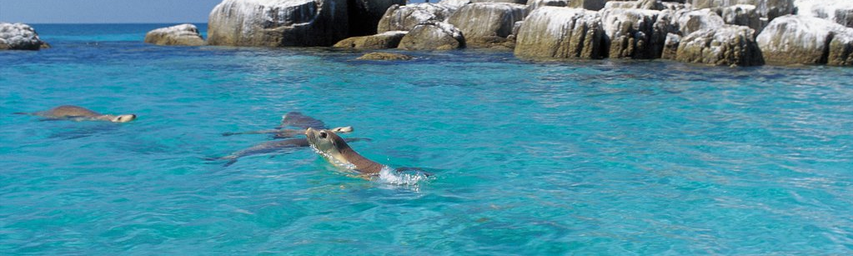
PORT LINCOLN FLY-IN

MARCH 14 – 18 2024

Click or tap to enter. Click or tap to enter.

Click or tap to enter. Click or tap to enter.

Click or tap to enter.

Click or tap to enter.

Click or tap to enter.

REGISTRATION FEE
Click or tap to enter. @ $600 PER PERSON = $ Click or tap to enter.
INCLUDES AIRPORT TRANSFERS, BUSES, TOURS AND SOME MEALS ( EXCL. BREAKFAST)

PAYMENT VIA DIRECT DEPOSIT
AUSTRALIAN MOONEY PILOTS ASSOC.

BSB: 035047 ACC: 156723
IN THE "DETAILS TO PAYEE" FIELD, PLEASE PUT YOUR SURNAME FIRST, FOLLOWED BY "YPLC"

PLEASE SUBMIT COMPLETED FORMS TO president@mooney.org.au
by 11 February 2024

www.mooney.org.au

