Orange Fly-in Registration Form

NAME:Click to enter. AIRCRAFT REG.:Click to enter
PHONE:Click to enter. EMAIL:Click to enter.
ETA ORANGE:Click to enter.
ACCOMPANIED BY:Click to enter.
SPECIAL DIETARY NEEDS:Click to enter.

REGISTRATION FEE
NUMBER ATTENDING:Click to enter. @ $450 PER PERSON = $Click to enter.
INCLUDES BUSES, COACHES, TOURS AND MOST MEALS ( EXCL BREAKFAST)

PAYMENT VIA DIRECT DEPOSIT
AUSTRALIAN MOONEY PILOTS ASSOC.

BSB: 035047 ACC: 156723
IN THE "DETAILS TO PAYEE" FIELD, PLEASE PUT YOUR SURNAME
FIRST, FOLLOWED BY "ORANGE"

PLEASE SUBMIT COMPLETED FORMS TO SECRETARY@ MOONEY.ORG.AU

WWW. MOONEY. ORG. AU

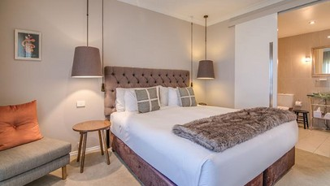
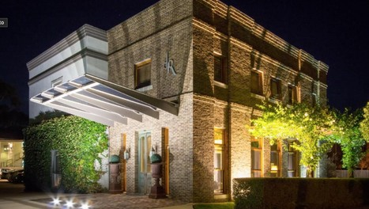
DE RUSSIE HOTEL WWW.DERUSSIEHOTELS.COM.AU PH: 02 6360 0973

Orange Accommodation

FRI: $284 SAT: $284 SUN: $265

CENTRAL CALEULA MOTEL WWW.CENTRALCALEULA.COM.AU PH: 02 6362 7699

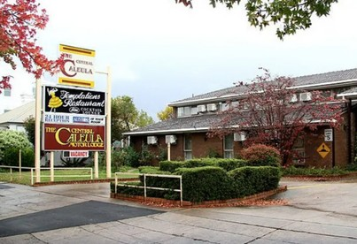
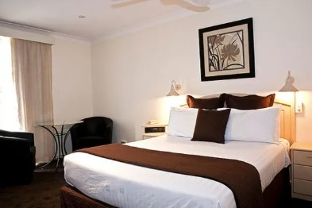
SINGLE
$175PN

DOUBLE
$195PN

PLEASE MENTION YOU ARE FROM AMPA WHEN BOOKING!
WWW.MOONEY.ORG.AU

