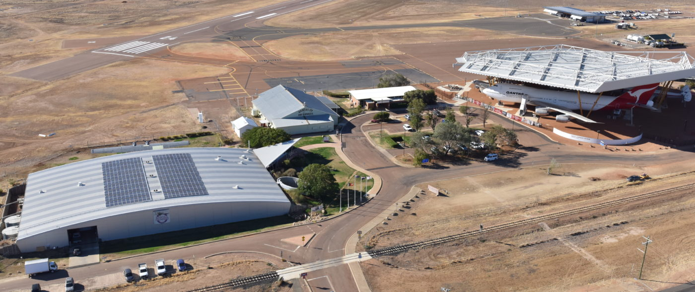

NAME: Click to enter. AIRCRAFT REG:. Click to enter

MOBILE PHONE: Click to enter. EMAIL: Click to enter.

ETA YLRE: Click to enter

ACCOMPANIED BY: Click to enter names.

SPECIAL DIETARY NEEDS: Click to enter

REGISTRATION FEE:

REGISTRATION: No. Click to enter @ $550 per person $Click to enter

PAYMENT: By direct deposit to:
Australian Mooney Pilots Assoc. BSB: 035047, Account #: 156723
(In the “Details to Payee” field, please put your SURNAME FIRST followed by AGM)

ACCOMMODATION:

Longreach Motor Inn, 84 Galah St., Longreach. Please make your own reservations as early as possible by calling the motel on (07) 4658 2322. See page 2 for rates.

There are 20 rooms held for AMPA. There is no penalty for cancellations more than 30 days prior to arrival but substantial fees apply for later cancellations.

Please return your completed form by 16th FEBRUARY to the convenor, Howard Hobbs at: hh643@bigpond.net.au
FLY-IN DETAILS
ACCOMMODATION OPTIONS
Longreach Motor Inn:

- Standard queen room $175/night
- Twin room $188/night
COSTS
Registration fee includes:
- Thursday
  - Transport from and to airport has been arranged with the motel but will depend on availability of their courtesy bus
  - Welcome dinner
- Friday
  - Rosebank Station tour and morning tea
  - Longreach town tour
  - Sunset cruise
- Saturday
  - Qantas Founders Museum entry, guided airpark tour, and lunch
  - Australian Stockman’s Hall of Fame Museum entry
  - Camden Park Station sunset tour with nibbles, dinner and drinks
- Sunday
  - Lunch at the Wellshot Hotel
  - Ilfracombe town tour & The Machinery Mile
  - Dinner at the local’s favourite pub “The Birdcage Hotel” (drinks at own expense)
Not included:
- Accommodation
- Breakfast daily
- Welcome dinner on Thursday evening
- Friday dinner at Branch Cafe

PROGRAM
Thursday 16th March - Arrival Day
From 13:00 Arrival at YLRE.
Longreach Motor Inn will transfer from Longreach Airport to accommodation
18:00 Dinner at Longreach Motor Inn, Harry’s Restaurant (own expense)

Friday 17th March
Rosebank Station Tour and Morning Tea.
Outback Aussie Tours Longreach Town Tour
Lunch and free time in town
Smithy’s Sunset Cruise on the Thomson River.
Transfer to The Branch Café
Following dinner walk back to your accommodation
Saturday 18th March
Qantas Founders Museum Entry, Guided Airpark Tour, and Lunch
Australian Stockman’s Hall of Fame Museum Entry
Camden Park Station Sunset Tour with Nibbles, Dinner and Drinks
Sunday 19th March
AGM approx. 09:30 -12:00 at (TBC)
Lunch at the Wellshot Hotel.
Ilfracombe Town Tour & The Machinery Mile.
Dinner at the local’s favourite pub “The Birdcage Hotel”
Monday 20th March - Departure Day

From 9.00 Departure from YLRE
Own transport to airport

