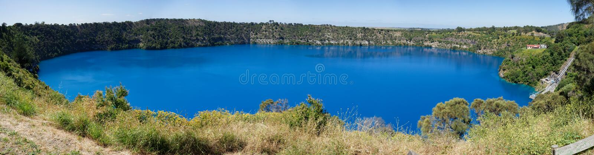

NAME: Click to enter. AIRCRAFT REG:. Click to enter

MOBILE PHONE: Click to enter. EMAIL: Click to enter.

ETA YMTG: Click to enter

ACCOMPANIED BY: Click to enter names.

SPECIAL DIETARY NEEDS: Click to enter

REGISTRATION FEE:

REGISTRATION: No. Click to enter @ $300 per person $Click to enter

PAYMENT: By direct deposit to:
Australian Mooney Pilots Assoc. BSB: 035047, Account #: 156723
(In the “Details to Payee” field, please put your SURNAME FIRST followed by 22AGM)

ACCOMMODATION:

The Commodore, Penola Road, Mt. Gambier. Please make your own reservations by 28 February by calling the motel on (08) 8724 6400. See page 2 for rates.

There are 15 apartments held for AMPA until 19 February. Later bookings can still be made but rooms are not guaranteed. Bookings can be cancelled without penalty up to 48 hours prior to arrival.

Please return your completed form by 28th FEBRUARY to the convenor, John Smith at: leonardjsmith@bigpond.com
FLY-IN DETAILS
ACCOMMODATION OPTIONS
The Commodore:
Studio Terrace Room - $166 per night
1 Queen Bed - Refurbished rooms with a private outdoor terrace

Studio Twin Room - $191 per night
1 King Bed, 1 King Single Bed – Refurbished room with a view that overlooks Frew Park
Rooms contain small kitchenette with microwave, kettle and toaster.

Grand King Room - $180 per night
1 King Bed – Most recently refurbished rooms

Sister property - The Henty (for late bookings)

Deluxe Twin Room - $135 per room per night
2 Queen Beds - Refurbished rooms.

Family Room - $143 per room per night
1 Queen, 2 single beds – Refurbished rooms.

Standard Double Room - $127 per room per night
1 Queen Bed - Non refurbished rooms.

COSTS
Registration fee includes:
- Bus transport Friday, Saturday, Sunday
- Welcome dinner Thursday evening
- Admission charges where required
- Picnic lunch Sunday
- Farewell dinner Sunday evening
Not included:
- Transport from and to airport
- Breakfast daily
- Lunch Friday and Saturday
- Dinner Friday and Saturday

PROGRAM
Thursday 17th March - Arrival Day
From 13:00 Arrival at YMTG.
Own transport to accommodation
18:00 Welcome dinner at The Commodore (included in registration)

Friday 18th March
09:00 Bus departs Commodore Motel for Penola (Mary McKillop centre), Hollick cellar door for tasting and food (www.hollick.com)
16:00 Bus returns to motel
19:00 Dinner at RSL Club at own cost (15 minute walk from motel)

Saturday 19th March
09:30 Bus departs Commodore Motel for tour to Umpherstone Sink Hole; Blue Lake; lunch at Bellum Hotel; Dingley Dell (home of Adam Lindsay Gordon)
16:00 Bus returns to motel
19:00 Dinner at Wild Ginger Thai or Café Belgiorno at own cost (10 minute walk from motel)

Sunday 20th March
09:00 Annual General Meeting at Commodore Motel
10:30 Bus departs Commodore Motel for tour to Engelbrecht Cave, Piccaninnie Ponds and Nelson Aeroplane Company;
Picnic lunch en route
15:00 Bus returns to motel
18:00 Bus departs Commodore Motel for farewell dinner at The Barn (included in registration)

Monday 21st March - Departure Day

From 9.00 Departure from YMTG
Own transport to airport

